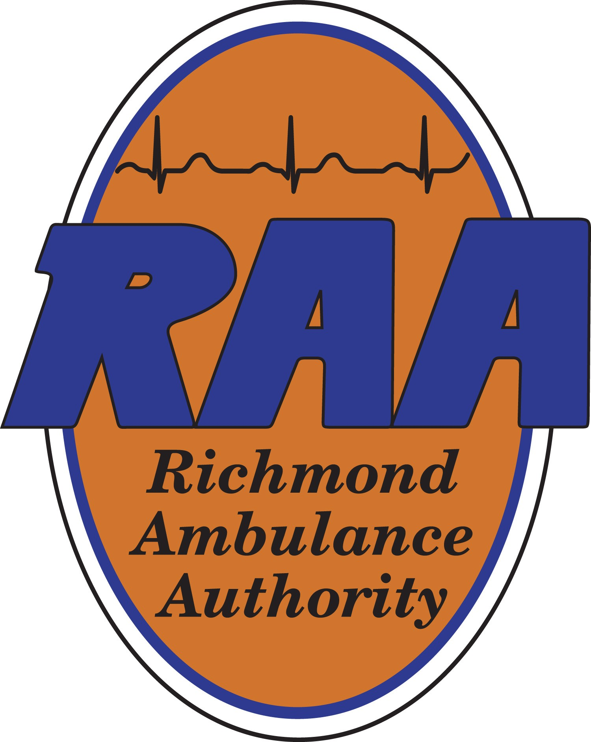

Richmond Ambulance Authority
Board Of Directors Meeting Minutes
August 19, 2025

Present: Weet Baldwin, Chairman

Julia Hammond, Vice Chairperson

Kirk Roberts, Treasurer

Marilyn West, Secretary

Odie Donald, Director

Mark Hickman, Director

Letitia Shelton, Director

Reva Trammell, Director

Joey Trapani, Director

Drew Walker, Director

Absent: Carlos Hopkins, Director

Counsel: Jonathan Joseph, Esq., Christian & Barton

Guests: Tom Ludin, EMS Coordinator, City of Richmond’s Department of Fire &

Emergency Services (RFD)

Staff: Chip Decker, Chief Executive Officer

Joseph Ornato, M.D., Operational Medical Director

Terone Green, Chief Administrative Officer

Ryan Martinette, Chief Operating Officer

Wayne Harbour, Chief Clinical Officer

Angel Dove, Chief Human Resources Officer

Laura Bickham, Senior Executive Assistant and Assistant Secretary to the

Board of Directors

- CALL MEETING TO ORDER

Weet Baldwin called the meeting to order at 12:05pm. He then welcomed Letitia Shelton, the City of Richmond’s Director of Finance, to the Board. He announced a number of Board reappointment applications were recommended for approval by Council’s Public Safety Committee at their meeting last month. They will be considered by the full Council at their meeting on September 8th.

- APPROVAL OF MINUTES

Motion: To approve the May 20, 2025 meeting minutes.

Made By: Julia Hammond Seconded: Marilyn West

Discussion: None

Motion Passed: The votes were recorded as follows:
Ayes: Nays:
Julia Hammond None
Marilyn West
Weet Baldwin
Mark Hickman
Kirk Roberts
Letitia Shelton
Reva Trammell
Joey Trapani
Drew Walker

- NEW BUSINESS
  - Group Health Benefits RFP

Motion: To approve the scoring criteria for the issuance of the Group Health Benefits Package Request for Proposals (RFP).

Made By: Julia Hammond Seconded: Drew Walker

Discussion: Chip Decker announced, later this year, RAA would need to issue an RFP for employee health benefits. He advised RAA’s benefits are currently provided through Anthem with the current contract set to expire on June 30, 2026. The RFP has been drafted and a licensed, insurance consultant will assist with the process. He requested a member of the Board to serve on the Selection Committee, to which Kirk Roberts volunteered. Weet Baldwin inquired about the timeline and Laura Bickham responded RAA will issue the RFP in late October. She noted the entire process would last approximately four months.

Kirk Roberts recalled the RFP process RAA completed for professional collection services. He noted the recent, legislative change prohibiting collection agencies from reporting health related debt to credit reporting agencies and advised there may have been a change based on the debt amount. Chip Decker commented the work to collect old, outstanding debt may not be worth the effort, explaining how it represents less than $200,000 of RAA’s revenue. Joey Trapani asked what percentage RAA’s outstanding collections represents, to which Chip Decker responded RAA brings in approximately $16 million in revenue so it is approximately 1.25%. Chip Decker stated EMS/MC, RAA’s outside billing company, makes every effort to collect on all old accounts before they are turned over to the collection agency. Mark Hickman asked who proposed the change to debt collection practices, to which Terone Green responded it was done at the federal level.

Chip Decker referred the Board to Page B1 of today’s meeting packet, which contained the proposed evaluation criteria for the issuance of the Health Benefits Package RFP. He explained Board approval of the evaluation criteria was necessary before the RFP can be finalized.

Motion Passed: The votes were recorded as follows:
Ayes: Nays:
Julia Hammond None
Drew Walker
Weet Baldwin
Kirk Roberts
Mark Hickman
Marilyn West
Letitia Shelton
Reva Trammell
Joey Trapani

- COMMITTEE REPORTS
  - Operations & Clinical: Ryan Martinette reported the following:
- The Committee met on August 14th, at which time, a status update on the acquisition of the chase cars was provided. RAA is scheduled to take delivery in September but this may be delayed due to several manufacturer recalls that must first be addressed.
- System compliance was 93.13% for May, 91.48% for June, and 90.49% for July. RAA continues working diligently to maintain adherence to response time targets since regaining system compliance back in February.
- RAA is beginning to use FirstWatch® demand analysis and scheduling modules to further enhance system efficiency. FirstWatch® is a platform that securely captures, translates and transmits information about 9-1-1 callers, patients and systems via their triggers, all in real-time.
- Ambulance availability continues to be the most challenging constraint followed by staffing limitations on specific days of the week. In September, RAA will be onboarding four additional non-emergency transport (NET) providers and 18 EMT Cadets.
- RAA budgeted $100,000 for its in-house medication exchange kit program. The program is well within this budget allocation, having spent $22,000. He reminded the Board RAA received a 50/50 match in grant funding through the State’s Office of EMS’ (OEMS) Rescue Squad Assistance Fund (RSAF). Kirk Robert asked if the $22,000 covered the cost of medication only or the administration of the program. Ryan Martinette responded it was for the purchase of medication.

Wayne Harbour reported the following:
    - The FirstWatch® team should have a first draft of RAA’s shift/FLOT reporting module completed this month. It will first require testing to ensure accuracy. RAA’s Data Integrity Committee provides information to the FirstWatch® team from RAA’s systems such as the Computer-Aided Dispatch (CAD), phones and radios.
    - The focus on RAA’s providers and a strong wellness program continue to be a top priority. In July, RAA hosted Struggle Well, a prevention-focused program based on posttraumatic growth, in partnership with the Richmond Police Department. The program was very well received by both RAA providers and RPD officers. Plans are underway to offer the course to Critical Incident Stress Management (CISM) and Peer Support teams. Other agencies have contacted RAA about the course as well.
    - RAA providers have completed training for the use of AI-generated narratives on electronic Patient Care Reports (ePCR’s) which was recently implemented in the field. The provider chooses the appropriate selection(s) of care administered and the narrative is then created based on those selections. This has taken stress off of crews and provides time-saving benefits as well.
    - RAA’s Safety & Risk Manager continues to focus on education for promoting provider injury reduction to include how to properly lift a patient.

- STAFF REPORTS
Chief Administrative Officer’s Report: Terone Green reported the following:
    - RAA is over one year into its contract with EMS/MC for billing services, commenting things are running smoothly.
    - RAA recently hired a Compliance Analyst.
    - A few office moves recently took place to help promote workflow efficiency and improve collaboration.

Chief Human Resources Officer: Angel Dove reported the following:
      - On September 8th, RAA will hold New Employee Orientation (NEO) with 18 EMS Cadets in attendance. There are currently 187 applications for EMS Cadet.
      - Last week, four providers were promoted to Paramedics.
      - RAA is pleased to announce its current retention rate is 76.11%.

Note: Odie Donald arrived to the meeting during the Chief Human Resources Officer’s report.

Chief Executive Officer’s Report: Chip Decker reported the following:
- No financial reports were included in today’s meeting packet due to the timing of RAA’s annual audit with CliftonLarsonAllen (CLA). CLA’s onsite review began yesterday and they will be at RAA for the week. June and July month-end reports, along with the FY2025 4th quarter financials, will be presented to the Finance Committee at their meeting on September 8th. Following, all reports will be distributed to the Board.
- The process for returning Emergency Medical Dispatch (EMD) call-taking to RAA is ongoing. Council is encouraged to assist with the process. Harm can be caused when calls are miscoded or miscategorized. The Department of Emergency Communications, Preparedness & Response’s (DECPR) union personnel are in favor of EMD call-taking returning to RAA. Weet Baldwin noted the Operations & Clinical Committee discussed the matter in detail at their meeting last week, adding their support for Chip Decker to move forward with what needs to be done to make the transition happen. Julia Hammond recalled a Board motion was passed at the May meeting in support of reassigning it back to RAA. Chip Decker reminded the Board RAA is an Accredited Center of Excellence (ACE), granted by the International Academies of Emergency Dispatch (IAED). It is the highest distinction an emergency communications center can achieve, demonstrating superior performance in areas like training, quality assurance and adherence to medical dispatch protocols. Since DECPR took over EMD call-taking, RAA is having to make double the number of changes in the acuity level of calls. Julia Hammond asked if this also affects the other call-taking disciplines (Fire and Police) to which Chip Decker responded affirmatively. He confirmed RAA is well-equipped to deal with non-violent, non-suicidal individuals without having to burden the Police Department. He stated RAA has been working on the duplication of questions callers have been asked for years, explaining most localities answer the phone, “Police, Fire or EMS/Ambulance?” while DECPR requests the caller’s name, address and phone number. As part of the accreditation requirement, RAA must ask these same questions when the caller is conferenced. Chip Decker suggested DECPR call-takers use the universal standard. Odie Donald stated that since this is a City Administration matter, they would take the lead on this.
- At the Board’s last meeting, the City’s former Interim-CAO confirmed RAA would be receiving the seven ambulances RAA needs, however, is seems the arrangements were not communicated to the City’s Fleet or Budget Offices. As a result, RAA’s FY2026 subsidy is severely underfunded. Currently, it can take anywhere from one to two years to build ambulances and take delivery. Weet Baldwin commented RAA would lose its place “in line” if an order is not placed soon. Reva Trammell expressed concern, adding she was informed the funding for the ambulances for RAA was included in this year’s budget. Chip Decker referenced his first meeting with Odie Donald yesterday, adding he informed Odie Donald about the matter at that time. He commented it was refreshing to learn about Odie Donald’s understanding of communication center operations. Marilyn West commented on the financial impact it would have should RAA lose its place in line noting there is no guarantee on price. Chip Decker explained the outlay for the City is currently $3.1 million for seven, fully equipped ambulances (to include stretchers and cardiac monitors).
- The RAA Annual Employee Appreciation will take place on Saturday, November 1st. Angel Dove added the event would take place from 3:00pm-6:00pm. The Board was requested to save the date with additional details to follow shortly.
- Since 2020, the City’s new radio system was set to “go live” by 2025, which has been pushed back to February 2027. He reminded the Board RAA previously paid for its portion of the project and is included in the City’s procurement and installation of the new system. Chip Decker was assured by Stephen Willoughby, Director of DECPR, the installation of RAA’s radio equipment would be completed.
- RAA received notification from the Virginia Department of Health (VDH) they are offering no-cost naloxone to EMS agencies, particularly those in “high and medium” priority areas, with Richmond defined as a “medium” priority area. RAA responses to overdoses are declining. Historically, overdoses were in the top ten list of call types, however they now rank twelfth or thirteenth. This may be attributed to the availability of naloxone in the field. Tom Ludin confirmed the Richmond Fire Department received the same notification from VDH. Chip Decker advised the City recently installed harm reduction vending machines aimed at preventing overdoses and supporting residents living with substance use disorders. The machines include naloxone, fentanyl test strips and personal hygiene items.

- OPERATIONAL MEDICAL DIRECTOR’S REPORT: Joseph Ornato reported the following:
    - Every month, he meets with individuals seeking to become advanced providers after completing a formal preception process. He advised he cleared one provider with four additional individuals seeking clearance. The process is a multifaceted evaluation of a person’s qualifications, competence and readiness to deliver advanced medical care in the field. RAA’s system uses EMT’s to handle more straightforward, non-critical calls whereas highly-trained providers are sent to higher acuity calls. This system works very well. RAA employs the most experienced providers with the highest level of certification possible. Mark Hickman asked what level of provider Dr. Ornato is clearing, to which Dr. Ornato responded these providers are advanced level paramedics. He explained he has a checklist of items he reviews with these individuals, commenting he relies very heavily on the preception process to assure his level of confidence in their abilities. Ryan Martinette shared his experience having been through a preception process in other localities in addition to Richmond with Dr. Ornato, commenting the preception process at RAA is by far one of the best.
    - Ryan Martinette stated he continues to review the chase car program data and reported there is a 20% transport ratio. He added RAA’s chase car paramedics (referred to as “chase paramedics”) respond to the highest acuity calls within seven minutes. The remaining 80%, chase paramedics are available to respond to the next call. He commented he can see other EMS systems moving toward a similar tiered-response system. Dr. Ornato recalled the recent National Association of EMT’s (NAEMT) webinar, Data Driven Deployment Decisions: Using YOUR Data for Effective EMS System Redesign, he co-presented with Ryan Martinette, adding the beauty of medical dispatch at RAA is that it works as it should. Weet Baldwin emphasized the importance for the Board to understand what takes place “behind the scenes” to appreciate what RAA does is truly unmatched.

Julia Hammond provided the Board with a Personnel Committee update. Two years ago, the process for the annual performance evaluation for Chip Decker was changed. Prior to 2023, the Board would receive Chip Decker’s completed self-evaluation. It was determined it would be best the Board receive RAA’s data and information to more objectively evaluate his performance. The Board now receives a “Year in Review,” summary along with the blank evaluation form to complete. The Board can also refer to the daily Word on the Street (WOTS), the monthly newsletter and may also wish to consider topics covered in Board and Committee meetings to assist with completing the form.

The form contains numeric scoring in addition to a section for optional commentaries. Once completed, the forms are returned to Julia Hammond for scoring purposes and a Personnel Committee meeting is scheduled. The Committee’s recommendation is then brought to the full Board for consideration at the November meeting. She expressed her appreciation for as much participation from the Board as possible.

- NEXT MEETING DATES

Weet Baldwin requested each member provide an introduction for RAA’s newest members. At the conclusion, he noted the dates of the upcoming meetings, which are as follows:

  - November 18, 2025
  - February 17, 2026

- ADJOURNMENT

Motion: To adjourn the August 19, 2025 meeting of the RAA Board of Directors.

Made By: Marilyn West Seconded: Julia Hammond

Discussion: None

Motion Passed: The votes were recorded as follows
Ayes: Nays:
Marilynn West None
Julia Hammond
Weet Baldwin
Kirk Roberts
Mark Hickman
Odie Donald
Letitia Shelton
Reva Trammell
Joey Trapani
Drew Walker

Note: The meeting adjourned at 12:55pm.

____________________________________________
Laura Bickham, Assistant Secretary

