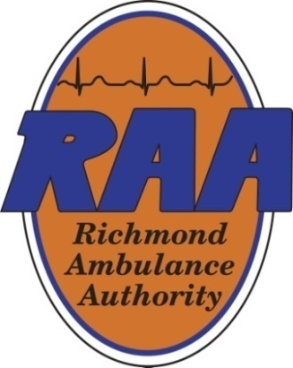 | Operations & Clinical Committee Meeting  October 30, 2025  1:00pm  Boardroom
Committee Members: | Weet Baldwin, Chair, Julia Hammond, Marilyn West, Carlos Hopkins
Staff Members: | Ryan Martinette, Chief Operating Officer, Wayne Harbour, Chief Clinical Officer, Chip Decker, Chief Executive Officer, Joseph Ornato, M.D., Operational Medical Director
Agenda Topics:
- Call Meeting to Order
Operations Update
- Chase Car Update
- System Compliance
Clinical Update
- Education and Training
- First Watch® Data Collection
- Safety & Risk Update
- FY2026 Ambulance Lease
- Other Comments
- Adjournment
Minutes from the August 14, 2025 Meeting:
Members Present: Weet Baldwin, Marilyn West, Carlos Hopkins, Julia Hammond
Marilyn West moved to approve the minutes from the 5/14 meeting. Carlos Hopkins seconded the motion and the motion passed unanimously.
OPERATIONS UPDATE: Ryan Martinette reported the following:
Chase Car Update: RAA is scheduled to take delivery in September, but this may be delayed due to several manufacturer recalls tied to the Expedition model that first need to be addressed. The delivery timeline is highly dependent on parts’ availability.
System Compliance: System compliance was 93.13% for May, 91.48% for June, and 90.49% for July. RAA continues working diligently to maintain adherence to response time targets since gaining system compliance back in February. RAA has begun using FirstWatch® demand analysis and scheduling modules to further enhance system efficiency. Ambulance availability continues to be the most challenging constraint for further improvement, followed by staffing limitations on specific days of the week. RAA will be onboarding four additional non-emergency transport (NET) providers and 18 EMT Cadets in September to backfill healthy attrition that has occurred over the summer.
In-House Medication Exchange Kit Program: RAA is averaging about 12 BLS medication kits/day and six ALS medication kits/day. Since going live with the program, RAA has spent $22,427 with the program well within the budget allocation of $100,000. 50% of RAA’s costs for the program will be reimbursed through the Rescue Squad Assistance Fund (RSAF) grant RAA received in January (with up to a maximum of $52,500 to be matched).
CLINICAL UPDATE: Wayne Harbour reported the following:
First Watch® Data Collection: The FirstWatch® team should have a first draft of RAA’s shift/FLOT reporting module completed this month. It will first require testing to ensure accuracy. RAA’s Data Integrity Committee provided information to the FirstWatch® team from RAA’s systems such as the Computer-Aided Dispatch (CAD), phones and radios.
Wellness Training: The “Struggle Well” class was successful, with positive feedback received from the RPD officers who attended alongside RAA field providers. The plan is to offer this course again to RAA’s Critical Incident Stress Management (CISM) and Peer Support teams. Other agencies have reached out expressing interest in the class having seen information about it in RAA’s Word on the Streets (WOTS).
Provider Documentation Education: RAA providers have completed training for the use of AI-generated narratives on electronic Patient Care Reports (ePCR’s) which was recently implemented in the field. The provider chooses the appropriate selection(s) of care administered and the narrative is then created based on those selections. This has taken stress off of crews and provides time-saving benefits as well.
Safety & Risk Update: The focus continues to be on education for promoting provider injury reduction to include how to properly lift a patient.
Emergency Medical Dispatch (EMD) Call-Taking Update: Chip Decker noted the ongoing efforts to transition EMD call-taking back to RAA. He advised he has an upcoming meeting with Odie Donald, at which time, he plans to familiarize him with the matter. Council is currently working on putting a paper together in support of returning it to RAA. Chip Decker also stated he plans to discuss the FY2026 city ambulance purchase/lease to RAA with Odie Donald as well.
Other Comments: Joseph Ornato announced he will be receiving the American College of Emergency Physicians’ (ACEP) Award for Outstanding Contribution to Research at their Annual Meeting taking place in Salt Lake City, UT on September 8th. The Committee congratulated him for receiving this recognition.

The meeting was adjourned at 1:10pm.
.

