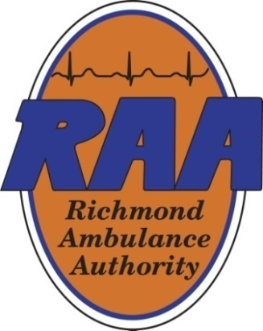 | Personnel Committee Meeting  October 30, 2025  12:00pm  Boardroom
Committee Members: | Julia Hammond-Chair, Weet Baldwin, Drew Walker, Marilyn West
Staff Members: | Angel Dove, Chief Human Resources Officer, Chip Decker, Chief Executive Officer
Agenda Topics:
- Call Meeting to Order
- Staffing Update
- Executive Session - Discussions Involving Personnel Matters
- Other Comments
- Adjournment

Minutes from the October 29, 2024 Meeting:
Committee Members in Attendance: Julia Hammond, Weet Baldwin, Marilyn West, Sheila White, Drew Walker-via telephone
**The minutes follow the order of business and not the meeting agenda**
- Julia Hammond called the meeting to order at 11:05 a.m.
- Marilyn West moved to approve the minutes from the November 9, 2023 meeting. Sheila White seconded the motion and the motion passed unanimously.
- Angel Dove outlined the proposed changes to the Employee Handbook, which include the addition of PRN Part-Time Employee and the addition of the minimum, required hours to be worked by a Regular Part-Time Employee. PRN (Latin phrase for “Pro Re Nata”) was also added to the Appendix of the Handbook. Marilyn West moved to recommend the Board adopt the proposed changes to the Handbook as presented to the Committee at today’s meeting. Weet Baldwin seconded the motion and the motion passed unanimously.
- Angel Dove provided the Committee with a staffing update: RAA requires 11 full-time BLS providers out of 88 to be fully staffed and 15 full-time ALS providers out of 39 to be fully staffed. Eleven BLS providers are scheduled to complete Paramedics class (at Brightpoint Community College) in March. She reported turnover is down 17.4% from last year, which she attributed to the different approach RAA has taken with recruitment. Management works closely with staff and she explained the Clinical team holds midpoint meetings with new providers, which is the halfway point of the preception phase to discuss provider performance. Additionally, RAA is offering a more competitive pay. She explained a stronger focus on retention is also a contributing factor to the lower turnover rate.
- Angel Dove announced RAA recently hired a new Talent Acquisition Specialist, Zandra Yacoviello, and complimented her for her driven approach to recruitment. She attended nine job fairs in September. Richmond Public Schools (RPS) recently updated their website which now highlights RAA’s EMT Cadet Program.
- Laura Bickham noted Drew Walker’s presence at the meeting (via telephone). Weet Baldwin requested, in accordance with Board policy, he announce his name, current location and the reason for the request to join the meeting remotely. Drew Walker stated his name and advised he was at Parham Doctors’ Hospital. He explained the Chief Operating Officer and Chief Nursing Officer for the hospital were not onsite, requiring him to remain on campus and join the meeting remotely. Weet Baldwin moved to allow Drew Walker to join the meeting remotely. Marilyn West seconded the motion and the motion passed unanimously. Following, Angel Dove provided Drew Walker with a recap of the discussion regarding the drop in RAA’s turnover. She commended Ryan Martinette, RAA’s Chief Operating Officer, for his increased visibility in the field and the positive impact it has had on providers.
- Marilyn West moved that the Personnel Committee of the Richmond Ambulance Authority enter into Executive Session pursuant to Section 2.2-3711(A)(1) for purposes of discussions involving personnel matters. Weet Baldwin seconded the motion and the motion passed unanimously. Weet Baldwin moved to return to the normal order of business and the parties certified no matters were discussed other than the agenda items. Sheila White seconded the motion and the motion passed unanimously.
- No other business was discussed and Julia Hammond adjourned the meeting at 11:50 a.m.

