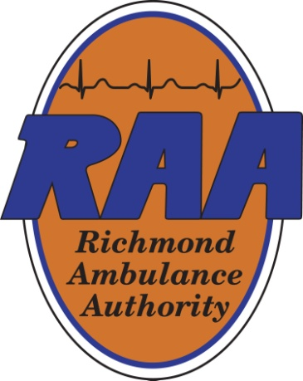 | Finance Committee  November 5, 2025  12:00 pm  RAA Boardroom
Committee Chair: | Kirk Roberts
Committee Members: | Weet Baldwin, Mark Hickman, Carlos Hopkins and Joseph Trapani
Staff Members: | Chip Decker, Chief Executive Officer; Terone Green, Chief Administrative Officer; Wanda Thomas, Director of Reimbursement; and Bryan Aud, Director of Finance (Committee contact: baud@raaems.org or 804-254-1152)
Guest(s): | CliftonLarsonAllen (CLA) staff
 | Agenda topics
- Call to Order
- Conference Call Attendee(s) – If Applicable
- Reading and approval of the minutes from the previous meeting (9/8/25)
- Review of the FY2025 Draft Audited Financial Statements – Presented by CLA
- Review of the FY2026 September Financial Statements
- Review of the VML/VACo Finance Lease purchase estimate for 7 ambulances and necessary equipment for each.
- Impact of Federal Shutdown
- Other Updates and Discussions
- Adjournment

Minutes from the September 8, 2025 meeting:
In attendance: Kirk Roberts, Weet Baldwin, Carlos Hopkins and Mark Hickman (via MS Teams); Not in attendance: Joseph Trapani; Other Board Members: None; Staff Members: Chip Decker, Terone Green, Wanda Thomas and Bryan Aud; Guests: None
Agenda Topics:
- Approval to meet via Electronic Means – Approval for Mark Hickman
- The minutes of the previous meeting (5/7/25) were approved.
- The FY2025 June Financials were reviewed with Committee approval.
- The FY2026 July Financials were reviewed with Committee approval.
- Chip discussed issues with no City funding for our ambulance purchase although funding had been approved by the prior administration.
- The meeting was adjourned.

Since the last meeting:
The FY2026 August Financial Statements were emailed to all Committee Members.

